Transmitter Signal Path
Each transmitter has an independent signal path including separate digital filters, DACs, analog low-pass filters, and I/Q mixers that drive the signal outputs. Data is input to the Tx signal path via the JESD204B high-speed serial data interface at the IQ data rate of the transmitter profile. The serial data is converted to parallel format through the JESD204B deframer into I and Q components. The data is processed through digital filtering and signal correction stages and input to I/Q DACs. The DAC output is low pass filtered by the Tx low-pass filter (LPF) and input to the up-conversion mixer. The I and Q paths are identical to one another. Over-ranging is detected in the Tx digital signal path at each stage and limited to the maximum code value to prevent data wrapping. A block diagram of a Tx signal path is shown in Figure 106. Blocks that are not discussed in this section are faded.
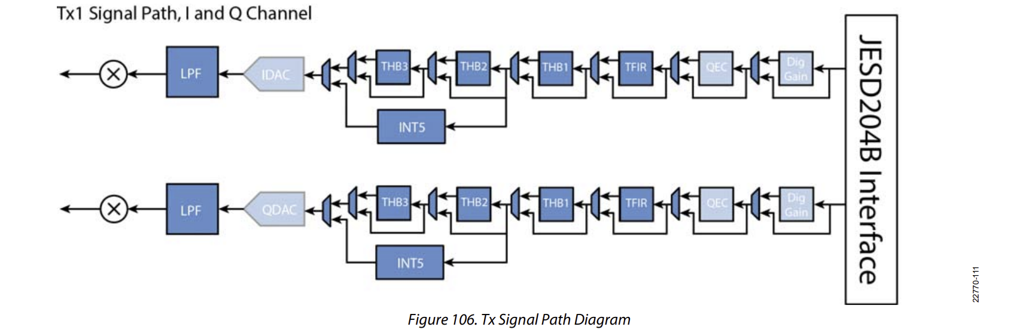

- Analog Low Pass Filter (LPF)
The LPF is a second-order analog Butterworth low pass filter with an adjustable 3dB corner. The Tx chains of the device can support pass-band bandwidths up to 225 MHz (on I and Q). The LPF is calibrated during device initialization, resulting in a consistent frequency corner across all devices. The LPF bandwidth is set within the device data structure and is profile dependent. Roll off within the analog LPF pass band is compensated by the TFIR to ensure a maximally flat pass-band frequency response.
- Interpolation By 5 Filter (INT5)
Either the INT5 or any combination of THB3 and THB2 are used in the Tx digital path. The INT5 interpolates by a factor of 5. The INT5 coefficients are listed as follows: INT5 filter coefficients: 0.002929688, 0.029052734, −0.029296875, 0.03125, −0.012207031, −0.005859375, −0.056640625, 0.051513672, −0.055664063, 0.025390625, 0.020996094, 0.081298828, −0.057617188, 0.072509766, −0.045166016, −0.047607422, −0.095947266, 0.030517578, −0.071289063, 0.068603516, 0.093994141, 0.113769531, 0.030761719, 0.055419922, −0.103759766, −0.185791016, −0.185302734, −0.136962891, −0.037353516, 0.227050781, 0.518554688, 0.717285156, 0.928466797, 1.019287109, 0.928466797, 0.717285156, 0.518554688, 0.227050781, −0.037353516, −0.136962891, −0.185302734, −0.185791016, -0.103759766, 0.055419922, 0.030761719, 0.113769531, 0.093994141, 0.068603516, −0.071289063, 0.030517578, −0.095947266, −0.047607422, −0.045166016, 0.072509766, −0.057617188, 0.081298828, 0.020996094, 0.025390625, −0.055664063, 0.051513672, −0.056640625, −0.005859375, −0.012207031, 0.03125, -−0.029296875, 0.029052734, 0.002929688
- Transmit Half Band 3 (THB3)
The THB3 is a fixed coefficient half-band interpolating filter. THB3 can interpolate by a factor of 2 or it can be bypassed. The coefficients are listed as follows. THB3 filter coefficients: 0.125, 0.5, 0.75, 0.5, 0.125
- Transmit Half Band 2 (THB2)
The THB2 is a fixed coefficient half-band interpolating filter. THB2 can interpolate by a factor of 2 or it can be bypassed. The coefficients are listed below. THB2 filter coefficients: −0.08203125, 0, 0.58203125, 1, 0.58203125, 0, −0.08203125
- Transmit Half Band 1 (THB1)
The THB1 is a fixed coefficient half band interpolating filter. THB1 interpolates by a factor of 2 or it can be bypassed. The coefficients are listed as follows. THB1 filter coefficients: −0.002319336, 0, 0.003601074, 0, −0.004058838, 0, 0.004119873, 0, −0.006439209, 0, 0.009613037, 0, −0.012023926, 0, 0.014404297, 0, −0.018737793, 0, 0.024291992, 0, -0.030059814, 0, 0.037353516, 0, −0.048156738, 0, 0.062927246, 0, −0.084350586, 0, 0.122283936, 0, −0.209564209, 0, 0.635925293, 1, 0.635925293, 0, −0.209564209, 0, 0.122283936, 0, −0.084350586, 0, 0.062927246, 0, −0.048156738, 0, 0.037353516, 0, −0.030059814, 0, 0.024291992, 0, −0.018737793, 0, 0.014404297, 0, −0.012023926, 0, 0.009613037, 0, −0.006439209, 0, 0.004119873, 0, −0.004058838, 0, 0.003601074, 0, −0.002319336
- Programmable Transmitter Finite Impulse Response (TFIR)
The TFIR filter acts as an interpolating filter in the TX path. The TFIR may interpolate by a factor of 1, 2, or 4, or it can be bypassed. The TFIR is used to compensate for roll off caused by the post-DAC analog low pass filter. The TFIR has a configurable number of taps; either 20, 40, 60, or 80 taps can be used. The TFIR also has a programmable gain setting of +6 dB, 0 dB, −6 dB or −12 dB. The maximum number of taps is limited by the TFIR Clock Rate (Data Processing Clock − DPCLK). The maximum DPCLK is 1 GHz. The DPCLK is the high speed digital clock (HSDIG_CLK) divided by either 4 or 5 depending on the HSDIG_CLK divider setting. The DPCLK affects the maximum number of TFIR filter taps that can be used according to the following relationship:
$${Tx PFIR filter taps}_{max}=\frac{{DPCLK}_{max}}{Tx_IQ_DataRate}×20$$

Receiver Signal Path
Each receiver input has an independent signal path including separate I/Q mixers that feed into programmable analog transimpedance amplifiers (TIA) that serve as low pass filters (LPF) in the analog data path. The signals are then converted by the sigma-delta ADCs and filtered in half-band decimation stages and the programmable finite impulse response filter (PFIR). The fixed coefficient half-band filters (FIR1, FIR2, RHB1(HR), RHB1(LP), RHB2, RHB3, DEC5) and the PFIR are designed to prevent data wrapping and over-range conditions. Each receiver channel can convert signals down to zero-IF real data using the standard I/Q configuration or a low-IF complex data configuration. The digital filtering stage allows the configuration flexibility and decimation options to operate in either mode. Figure 101 shows the signal path for the Rx1, Rx2, Rx3 and Rx4 signal chain. Blocks that are not discussed in this section are faded.
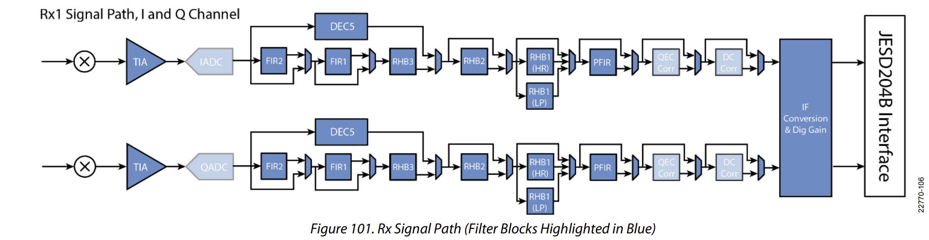
- Transimpedance Amplifier (TIA)
The Rx transimpedance amplifier is a low pass filter with a single real pole frequency response. The device supports bandwidths up to 200 MHz and thus each TIA supports a pass-band of 100 MHz on the I and Q paths. The TIA is calibrated during device initialization to ensure a consistent frequency corner across all devices. The TIA 3dB bandwidth is set within the device data structure and is profile dependent. Roll off within the Rx pass band is compensated by the PFIR to ensure a maximally flat pass-band frequency response.
- Decimation Stages
The signal path can be configured so that either the decimate-by-5 filter (DEC5) or the combination of FIR2, FIR1, and RHB3 is used in the Rx digital path. The DEC5 decimates by a factor of 5 while the other filter combination can be configured to decimate by factors of 2, 4, or 8.
- DEC5
DEC5 filter coefficients: 0.000976563, 0.001220703, 0.001953125, 0.001953125, −0.00390625, −0.0078125, −0.014648438, −0.018798828, −0.019042969, -0.007568359, 0.010742188, 0.041748047, 0.079101563, 0.1171875, 0.146972656, 0.165527344, 0.165527344, 0.146972656, 0.1171875, 0.079101563, 0.041748047, 0.010742188, −0.007568359, −0.019042969, −0.018798828, −0.014648438, −0.0078125, −0.00390625, 0.001220703, 0.001953125, 0.001953125, 0.001220703, 0.000976563
- Finite Impulse Response 2 (FIR2)
The FIR2 filter is a fixed coefficient decimating filter. The FIR2 decimates by a factor of 2 or it may be bypassed. FIR2 filter coefficients: 0.0625, 0.25, 0.375, 0.25, 0.0625
- Finite Impulse Response 1 (FIR1)
The FIR1 filter is a fixed coefficient decimating filter. The FIR1 decimates by a factor of 2 or it may be bypassed. FIR1 filter coefficients: 0.0625, 0.25, 0.375, 0.25, 0.0625
- Receive Half Band 3 (RHB3)
The RHB3 filter is a fixed coefficient decimating filter. The RHB3 decimates by a factor of 2. RHB3 filter coefficients: −0.033203125, 0, 0.28125, 0.49609375, 0.28125, 0, −0.033203125
- Receive Half Band 2 (RHB2)
The RHB2 filter is a fixed coefficient decimating filter. The RHB2 decimates by a factor of 2 or it may be bypassed. RHB2 filter coefficients: −0.000244141, 0, 0.001708984, 0, −0.0078125, 0, 0.026855469, 0, −0.078369141, 0, 0.30859375, 0.501220703, 0.30859375, 0, −0.078369141, 0, 0.026855469, 0, −0.0078125, 0, 0.001708984, 0, −0.000244141
- Receive Half Band High Rejection 1 (RHB1 (HR))
The RHB1 (HR) filter is a fixed coefficient decimating filter. The RHB1 (HR) can decimate by a factor of 2, or it may be bypassed. RHB1 (HR) filter coefficients: 0.000106812, 0, −0.000289917, 0, 0.00062561, 0, −0.001205444, 0, 0.002120972, 0, −0.003494263, 0, 0.005493164, 0, −0.008300781, 0, 0.012207031, 0, −0.01763916, 0, 0.025421143, 0, −0.03717041, 0, 0.057250977, 0, −0.101608276, 0, 0.314498901, 0.495956421, 0.314498901, 0, −0.101608276, 0, 0.057250977, 0, −0.03717041, 0, 0.025421143, 0, −0.01763916, 0, 0.012207031, 0, −0.008300781, 0, 0.005493164, 0, −0.003494263, 0, 0.002120972, 0, −0.001205444, 0, 0.00062561, 0, −0.000289917, 0, 0.000106812
- Receive Half Band Low Power 1 (RHB1 (LP))
The RHB1 (LP) filter is a fixed coefficient decimating filter. The RHB1 (LP) can decimate by a factor of 2, or it may be bypassed. RHB1 (LP) filter coefficients: −0.002685547, 0, 0.017333984, 0, −0.068359375, 0, 0.304443359, 0.501708984, 0.304443359, 0, −0.068359375, 0, 0.017333984, 0, −0.002685547
- Rx Programmable Finite Impulse Response (PFIR)
The Rx PFIR filter acts as a decimating filter. The PFIR may decimate by a factor of 1, 2, or 4, or it can be bypassed. The RFIR is used to compensate for the roll-off of the analog TIA LPF. The PFIR can use either 24, 48, or 72 filter taps. The PFIR also has programmable gain settings of +6 dB, 0 dB, −6 dB or −12 dB.
The maximum number of taps is limited by the FIR Clock Rate (Data Processing Clock − DPCLK). The maximum DPCLK is 1 GHz. The DPCLK is the ADC Clock Rate divided by either 4 or 5. The divider is 4 when using the FIR2, FIR1 and HB3 filters, and it is 5 when using the DEC5 filter. The DPCLK affects the maximum number of PFIR filter taps that can be used according to the following:
$${Rx PFIR filter taps}_{max}=\frac{{DPCLK}_{max}}{Rx_IQ_DataRate}×24$$

Observation Receiver Signal Path
The device has four observation receivers (ORx1, ORx2, ORx3 and ORx4) that can be used to capture data for digital pre-distortion (DPD) algorithms and other measurements/calibration that require monitoring the transmitter outputs. The observation receiver can serve as an external loopback path to loop back the output of a PA, provided input level to the ORx is below the full-scale level of the ADC.
The devices ORx1, ORx2, ORx3 and ORx4 channels have separate I/Q mixers. These mixers are identical to the mixers of the receivers, with the exception that the observation mixers include an LO mux. The LO mux allows either the RF PLL or the AUX PLL to provide the local oscillator signal source for the ORx1, ORx2, ORx3 and ORx4 mixers.
The mixer feeds into a programmable transimpedance amplifier (TIA) that serves as a low pass filter (LPF) in the analog data path. The signal is converted by the sigma-delta ADC and filtered in halfband decimation stages and the programmable finite impulse response (PFIR). The fixed coefficient halfband filters (FIR1, RHB1(HR), RHB1(LP), RHB2, RHB3, DEC5) and the PFIR are designed to prevent data wrapping and overrange conditions.
The IF conversion stage provides the ability frequency shift or upsample/downsample digital data. Configurations supported include real IF (real valued baseband data) configuration and low IF (complex data) configuration.
The diagram in Figure 109 shows the signal path for an ORx signal chain. Blocks that are not discussed in this section are faded.
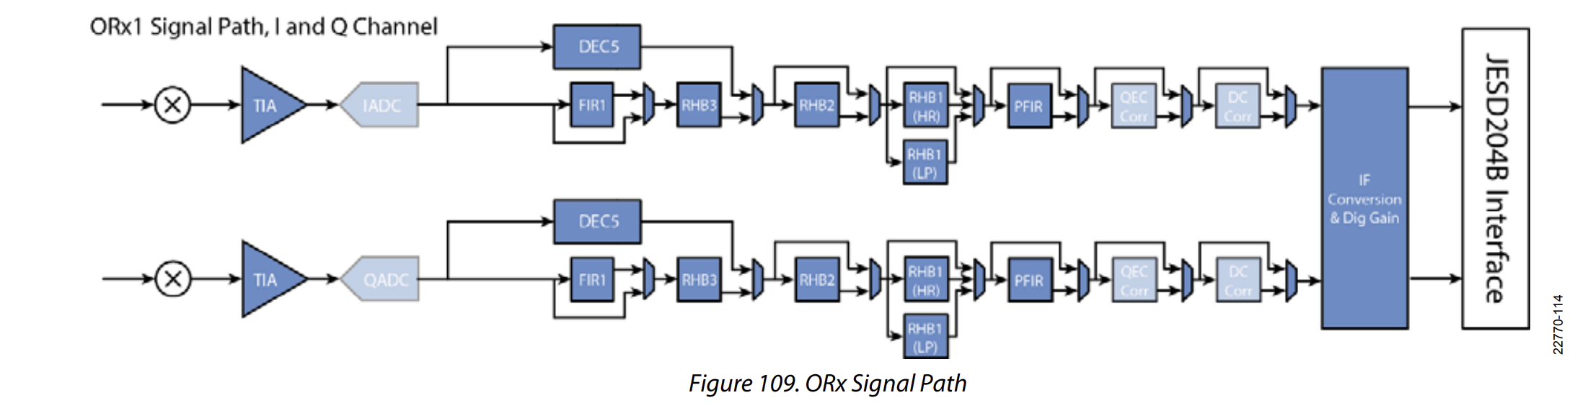
- Transimpedance Amplifier (TIA)
The ORx transimpedance amplifier is a low pass filter with a single real pole frequency response. The TIA can support pass-band bandwidths up to 225 MHz (for both I and Q). The TIA is calibrated during device initialization which ensures a consistent frequency corner across all devices. The TIA 3 dB bandwidth is set within the device data structure and is profile dependent. Roll-off within the ORx pass band is compensated by the PFIR to ensure a maximally flat pass-band frequency response.
- DEC5
Either the DEC5, or the combination of RHB3 and FIR1 is used in the Rx digital path. The DEC5 decimates by a factor of 5 or it may be bypassed. The DEC5 coefficients are listed below.
DEC5 filter coefficients: 0.000732422, 0.001464844, 0.002441406, 0.003417969, 0.003173828, −0.000732422, −0.005615234, −0.013183594, −0.020507813, −0.022949219, −0.014648438, 0.003417969, 0.035400391, 0.077392578, 0.119873047, 0.154541016, 0.176269531, 0.176269531, 0.154541016, 0.119873047, 0.077392578, 0.035400391, 0.003417969, −0.014648438, −0.022949219, −0.020507813, −0.013183594, −0.005615234, −0.000732422, 0.003173828, 0.003417969, 0.002441406, 0.001464844, 0.000732422
- Finite Impulse Response 1 (FIR1)
The FIR1 filter is a fixed coefficient decimating filter. The FIR1 decimates by a factor of 2 or it may be bypassed.
FIR1 filter coefficients: 0.25, 0.75, 0.75, 0.25
- Receive Half Band 3 (RHB3)
The RHB3 filter is a fixed coefficient decimating filter. The RHB3 decimates by a factor of 2 or it may be bypassed. The RHB3 coefficients are listed below.
RHB3 filter coefficients: −0.0625, 0.0078125, 0.5625, 0.984375, 0.5625, 0.0078125, −0.0625
- Receive Half Band 2 (RHB2)
The RHB2 filter is a fixed coefficient decimating filter. The RHB2 decimates by a factor of 2 or it may be bypassed. The RHB2 coefficients are listed below.
RHB2 filter coefficients: −0.002929688, 0, 0.018554688, 0, −0.0703125, 0, 0.3046875, 0.500976563, 0.3046875, 0, −0.0703125, 0, 0.018554688, 0, −0.002929688
- Receive Half Band 1 High Rejection (RHB1 (HR))
The RHB1 (HR) filter is a fixed coefficient decimating filter. The RHB1 can decimate by a factor of 2, or it may be bypassed. The RHB1 coefficients are listed as follows. RHB1 filter coefficients: −0.000732422, 0, 0.000732422, 0, −0.001098633, 0, 0.001586914, 0, −0.00213623, 0, 0.002929688, 0, −0.00378418, 0, 0.004882813, 0, −0.006225586, 0, 0.007873535, 0, −0.009887695, 0, 0.012329102, 0, −0.015380859, 0, 0.019226074, 0, −0.024353027, 0, 0.031555176, 0, -0.042419434, 0, 0.061462402, 0, −0.104797363, 0, 0.317871094, 0.5, 0.317871094, 0, −0.104797363, 0, 0.061462402, 0, −0.042419434, 0, 0.031555176, 0, −0.024353027, 0, 0.019226074, 0, -0.015380859, 0, 0.012329102, 0, −0.009887695, 0, 0.007873535, 0, −0.006225586, 0, 0.004882813, 0, −0.00378418, 0, 0.002929688, 0, -0.00213623, 0, 0.001586914, 0, −0.001098633, 0, 0.000732422, 0, −0.000732422
- Receive Half Band 1 Low Power (RHB1 (LP))
The RHB1 (LP) filter is a fixed coefficient decimating filter. The RHB1 can decimate by a factor of 2, or it may be bypassed. The RHB1 coefficients are listed below. RHB1 filter coefficients: −0.002685547, 0, 0.017333984, 0, −0.068359375, 0, 0.304443359, 0.501708984, 0.304443359, 0, −0.068359375, 0, 0.017333984, 0, −0.002685547
- PFIR
The PFIR filter acts as a decimating filter. The PFIR may decimate by a factor of 1, 2, or 4, or it can be bypassed. The PFIR is used to compensate for the roll off of the analog TIA LPF. The PFIR can use either 24, 48, or 72 filter taps. The PFIR also has programmable gain settings of +6 dB, 0 dB, −6 dB or −12 dB.
The maximum number of taps is limited by the FIR Clock Rate (Data Processing Clock - DPCLK). The maximum DPCLK is 1 GHz. The DPCLK is the ADC Clock Rate divided by either 4 or 5. It is 4 when using the HB2 and HB3 filters. It is 5 when using the DEC5 filter. The DPCLK affects the maximum number of RFIR filter taps that can be used according to the following relationship:
$${ORx PFIR filter taps}_{max}=\frac{{DPCLK}_{max}}{ORx_IQ_DataRate}×24$$

